

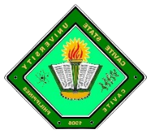**CAVITE STATE UNIVERSITY**

Imus Campus

Cavite Civic Center Palico IV, Imus, Cavite

(046) 471-66-07 / (046) 471-67-70/ (046) 686-2349

www.cvsu.edu.ph

**DEPARTMENT OF COMPUTER STUDIES**

**ITEC 60 – Integrated Programming and Technologies 1**

**Project Presentation**

Group # : **1**

Leader :

Members :

Course : **BSIT**

Section : **1X**

Title : **Jack en’ Poy**

Description : **Jack en Poy also known as Rock, Paper, and Scissors games is commonly played by kids. Kawan ng Cordero is the only Bible-based kiddie show on television. It stirs the interest of the young ones to fascinating facts and moral values written in the Bible.**

Features : **(List all the features of your system/game, mechanics, how to use/play)**

**(Features must be well-detailed or have a description that corresponds with your project)**

**Manage information –** the system is able to add, update and delete records and information with the use of admin user and so on and so forth.

**Prototype Screenshots: screenshots of all the listed features (Flow)**